Facebook

1. Logon to facebook.com in your web browser. You will need to be at least 13 years old to create a Facebook account. Facebook accounts are free, but you can purchase things for your Facebook account. You can only create one Facebook account per email address.

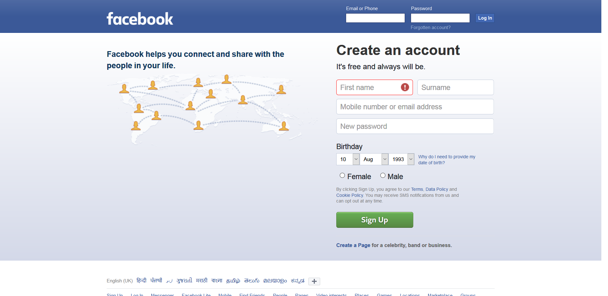

1. On the Facebook homepage, enter the name you go by in everyday life, your email address, a password you'll remember, your birthday, and your gender. You must use your real name for your account.

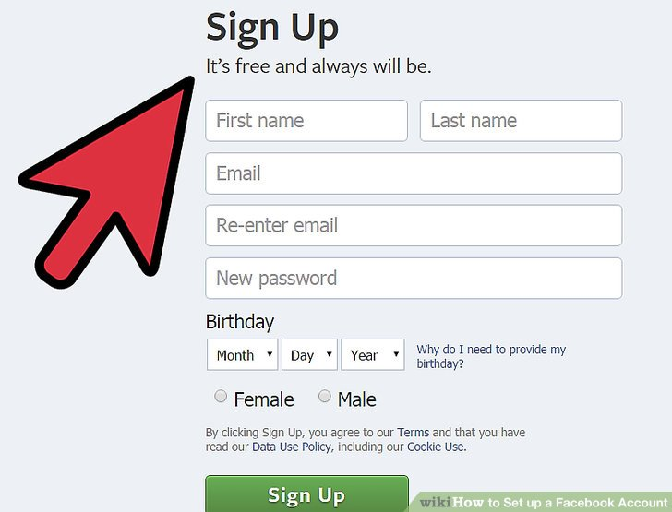

1. **Click the "Sign Up" button.** If all of your information is correct, you will be sent a verification email to the address you provided.

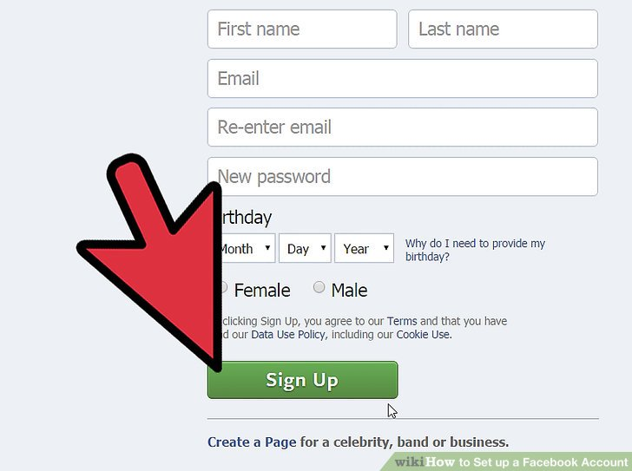

1. **Open the verification email.** It may take a few minutes for the email to get delivered. Click the link in the email to activate your account. To finish creating your account, you need to confirm your email or mobile phone number.